Fire Walk With Me  When  March 15th 2020  5pm – 9pm  Where  Ormsby Street,  London E2 8JG  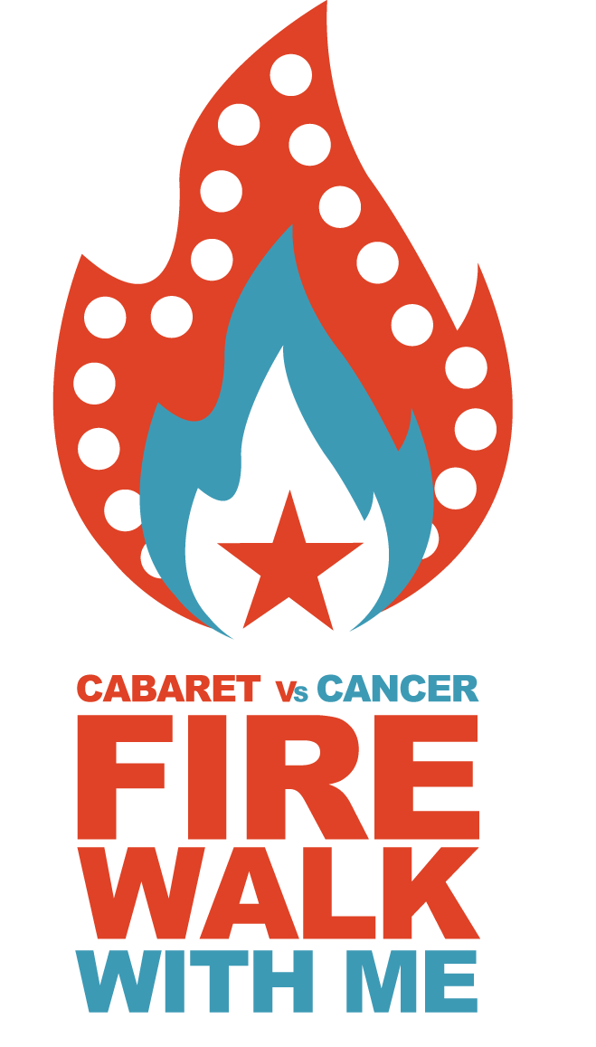 | Benefiting  Cabaret vs Cancer  Fire walking is a great way to challenge your perception of  what is humanly possible whilst raising money for Cabaret vs Cancer.  We are looking for 30 daredevils to walk across hot, smouldering coals to help us raise funds for families dealing with cancer and support child bereavement teams across London.  What happens on the day...  On the day you will receive 1 hour training prior to your  walk. This training will give you the motivation and confidence required to complete the challenge of fire  walking. The fire walk and training seminar is conducted  by BLAZE, one of the leading fire walk companies in  the UK.  Sign up today...  To sign up, simply complete the registration form and email back to us with your £25 registration fee cabaretvscancer@gmail.com
How Much Does it Cost?  To reserve your place there is an entry fee of £25. We then ask you to raise a minimum of £125 through sponsorship.  What time do I have to get there?  On the day registration will be open from 5pm. The training will start at 6pm (*subject to small changes)  Where will the fire walk take place?  At Randal Cremer Primary School, Ormsby Street, London, E2 8JG  Can I bring anyone with me?  Yes, the more people we have to encourage the fire walkers the better.  What age do I have to be?  14 is the minimum age, there is a form for your parent or guardian to sign.  Cancellation  In the unforeseen circumstance that the fire walk is unable to take place every attempt will be made to rearrange the date. Refunds will only be given if the fire walk is cancelled by Cabaret vs Cancer.  Alcohol  Alcohol must not be consumed prior to the fire walk or bought onto the premises. Admittance will be refused to anyone under the influence of alcohol or any other substances.  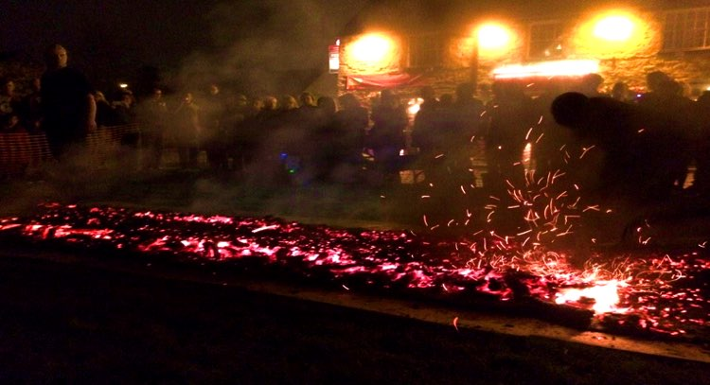 | Health and Safety  Cabaret vs Cancer to the extent permitted by law accepts no responsibility for loss, damage, injury, consequential loss suffered by any entrant personally or to their property as a result of their entry to or participation in the fire walk. All entrants must take responsibility for their own health and safety at all times  Clothing  You must wear comfortable clothing for the event. The fire walk will take place outside so please bring suitable clothing for the time of year.  Sponsor money  By signing up to the fire walk you agree to raise a minimum sponsorship of £125. Please bring all sponsorship money with you on the night. Please note it is a criminal offence to withhold any money raised, use money raised to cover expenses occurred by participation in this event or donate money to other charities.
Entry Form  Participant Details:  Name:  Address:  Contact Number:  Email:  Date of Birth:  Emergency Contact:  Name:  Contact Number:  Do you have any medical conditions or allergies to disclose?  Payment:  Please make payment via PayPal, and give details here:  Signed: Date | Declaration and disclaimer  By signing this entry form I confirm that I have read the conditions of entry. I understand that Cabaret vs Cancer will take no responsibility for injury or damage caused to myself or my property before, during or after the firewalk.  Photos  By signing this form I agree that my photo can be used at the discretion of Cabaret vs Cancer and Blaze UK.

